Cultura I.II.

A Young Inventor

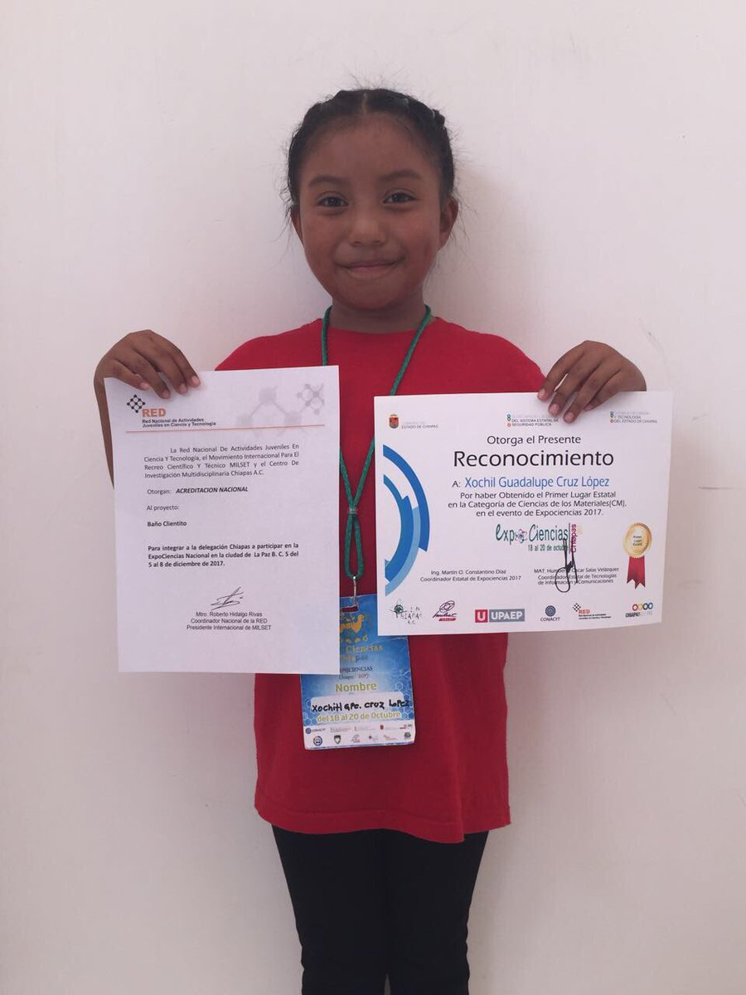

Parte 1:

Before reading the article, use [www.wordreference.com](http://www.wordreference.com) to look up the following vocabulary:

1. La inventora= inventor
2. Inspirar= inhale/breathe
3. Inventar=to invent
4. La ciencia=science
5. El premio=prize/award
6. El desarrollo=development/growth/progress
7. Reconocer= to recognize
8. El cambio climático=climate change
9. Combatir=to combat/fight against
10. Sostenible=sustainable

Parte 2:

Now, read [this article](https://www.globalcitizen.org/en/content/mexican-girl-science-prize-water-heater/) and answer the questions about what you learn. You do not have to watch the video embedded in the article to answer the questions.

1. The inventor recognized in this article is 8 years old.
2. **True** or false? A prestigious university awarded Srta. Cruz López her prize.
3. The prize recognizes women's accomplishments in science.
4. Xóchitl Guadalupe invented.

**a.) a water heater** c.) a solar stove

b.) a solar rooftop d.) a biodegradable material to replace plastic

1. She used ___________________ to construct her invention.

a.) glass panels c.) logs **e.) A and B**

b.) hoses d.) all of the above

1. People that live in her rural community are low income and need alternatives to cutting down trees for fuel.
2. Xóchitl Guadalupe wishes to inspire girls to succeed in science-related fields of study.
3. Mexico’s national agency for science and technology says that 36% of people in the country’s scientific register are women, which is a 65% increase over 2012.

a.) 40%, 46% c.) 20%, 5%

**b.) 36%, 65%**  d.) 50%, 75%

Parte 3:

Answer the questions **in Spanish in a complete sentence.**

20. ¿Cuál es el apellido de la chica (girl)? Alla chica es bido de las chicas Cruz López.

21. ¿De dónde es ella? Es de Mexico.

20. ¿Es importante combatir el cambio climático? No es importante combatir el cambio climático

21. ¿Te gusta la ciencia? Me gusta la ciencia.

22. ¿Eres inventor/a? No soy inventor/a.